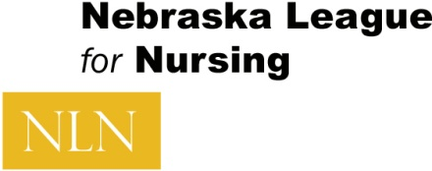

2015 NeLN Membership

It’s time to join the Nebraska League for Nursing.

Membership Application/Renewal

NAME:
(If you are renewing member only complete the following if there are changes.)
ADDRESS:
CITY, STATE, ZIP:
TELEPHONE: (H/C) (W)
E-MAIL:

POSITION:
AFFILIATION/EMPLOYER:

Dues: $30 for 1 year membership
$50 for 2 year membership
$75 for 3 year membership

----------------------------------------------------------------------------------------------------
Please enclose check made out to NeLN to:
Nebraska League for Nursing
Attn: Kassie McKenny, Treasurer
101 South 42nd Street
Omaha, Ne 68131-2739

NeLN Membership entitles members to the Nebraska Constituent League benefits only.
Membership does not include National League for Nursing member privileges.

