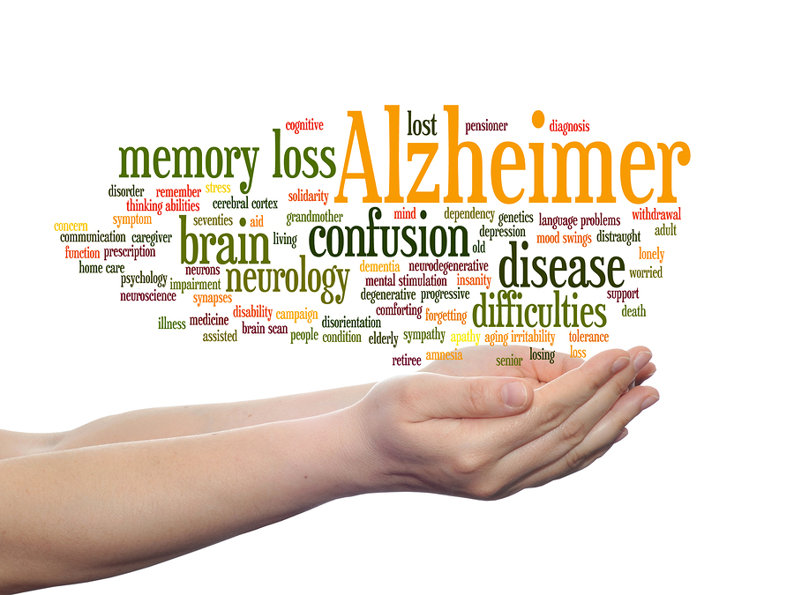
Have you cared for an individual with Alzheimer’s disease or maybe had someone you love impacted by this disease? Would you like to learn more about communication techniques in the setting of dementia; teamwork and collaboration in planning care for the client with AD; family support; ethical decisions and client advocacy?
50 million people worldwide are living with Alzheimer’s and other dementias.
Alzheimer’s disease is a degenerative brain disease and the most common form of dementia.

Making a Difference in Alzheimer’s Disease-Holistic Client Centered Care

You are invited to an educational event sponsored by the Nebraska League for Nursing (NeLN) and Omicron Epsilon (Clarkson College Chapter of Sigma) for an interprofessional educational event, because we are committed to raising awareness related to Alzheimer's care. Please join us!

Date: Thursday, Sept. 5th
Time: 5:00-6:00 pm, food provided
Location: Clarkson College, Room 308
Speakers: Barb Bayer MSN, RN
Community Educator
Alzheimer’s Association
and
Retired APRN from
Geriatric Psychiatry Outpatient Clinic
Nebraska Medicine
and

Julie Lawlor, MSN, RN
Assistant Professor
Baccalaureate Nursing
Clarkson College

This presentation is free and open to all. There will be a donation jar to raise money for the NeLN/Omicron Team for the Alzheimer’s walk 9/22/2019. We will also be ready to help individuals to sign up to join our team! Please RSVP to help us calculate amount of food needed for the event. Drop ins welcome as seating allows. Max capacity 60. RSVP http://evite.me/g23zEE9btn

